
Business Question and Visualization Report

Date | 31 October 2026
Team ID | Not applicable – Individual Project
Project Name | EV Market Performance & Insights
Maximum Marks | 5 Marks

Visualization development refers to the process of creating graphical representations of data to facilitate understanding, analysis, and decision-making. The goal is to transform complex datasets into visual formats that are easy to interpret, enabling users to gain insights and make informed decisions. Visualization development involves selecting appropriate visual elements, designing layouts, and using interactive features to enhance the user experience. This process is commonly associated with data visualization tools and platforms, and it plays a crucial role in business intelligence, analytics, and reporting
Business Questions and Visualisation
The process involves defining specific business questions to guide the creation of meaningful and actionable visualizations in Tableau. Well-framed questions help in identifying key metrics, selecting relevant data, and building visualisation that provide insights.
Project Business Questions and Visualisations

Note: Min 8 business question and visualisations Required inform of above

Business Questions and Visualisations
1. How have EV sales changed from 2021 to 2025?
• Visualization: Year-wise EV Sales Trend – line chart.
• Tableau measure: SUM([Annual Sales Units]) by Year.
• Observation: The submitted chart shows an increase from 400,000 in 2021 to 968,000 in 2025.
2. Which vehicle categories contribute more to EV sales?
• Visualization: EV Sales by Vehicle Category – bar chart.
• Tableau measure: SUM([Annual Sales Units]) by Vehicle Category.
• Observation: The visible chart compares categories including Sedan and SUV; SUV is higher in the submitted view.
3. Which battery technology has higher sales?
• Visualization: EV Sales by Battery Technology – bar chart.
• Tableau measure: SUM([Annual Sales Units]) by Battery Technology.
• Observation: The submitted chart shows NMC higher than LFP.
4. Which countries have higher EV sales?
• Visualization: EV Sales by Country – bar chart.
• Tableau measure: SUM([Annual Sales Units]) by Country.
• Observation: The chart compares China, France, Germany, India, Japan, South Korea and the USA.
5. How are EV sales distributed geographically?
• Visualization: Global EV Sales by Country – map.
• Tableau measure: SUM([Annual Sales Units]) by Country; Country is used as the geographic field.
• Observation: The map gives a geographic comparison of sales across the countries represented.
6. Which manufacturers contribute to EV sales?
• Visualization: EV Sales by Manufacturer – pie chart.
• Tableau measure: SUM([Annual Sales Units]) by Manufacturer.
• Observation: The pie chart compares contributions from BYD, Ford, Hyundai, Nissan, Renault, Tata Motors, Tesla and Volkswagen.
7. How does average vehicle price relate to customer rating?
• Visualization: Customer Rating vs Average Vehicle Price – scatter plot.
• Tableau measure: AVG([Price INR]) and AVG([Customer Rating]); Manufacturer distinguishes the marks.
• Observation: The scatter plot allows comparison of manufacturers by average price and customer rating.
8. What is the overall performance shown by the KPI cards?
• Visualization: KPI cards – Total EV Sales, Average Driving Range and Average Rating.
• Tableau measure: SUM([Annual Sales Units]); AVG([Driving Range KM]); AVG([Customer Rating]).
• Observation: The submitted dashboard screenshot displays 832,000 total sales, 480.6 km average range and 4.325 average rating.

Visualisation Screenshot Evidence
Dashboard overview with KPI cards, year-wise trend and category/battery charts
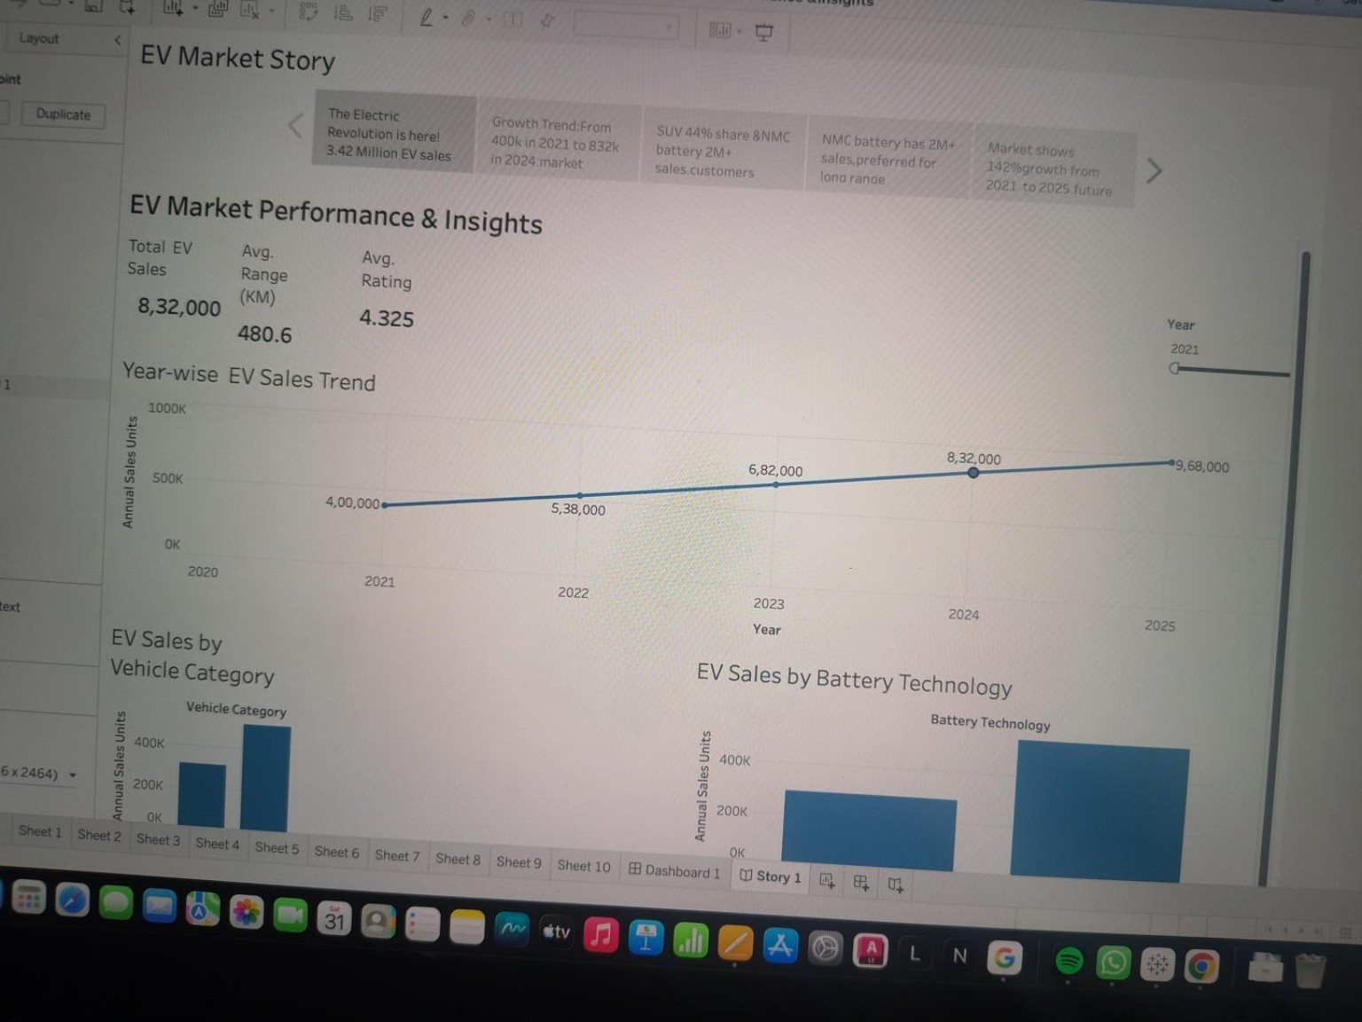
Country comparison and customer-rating versus price views
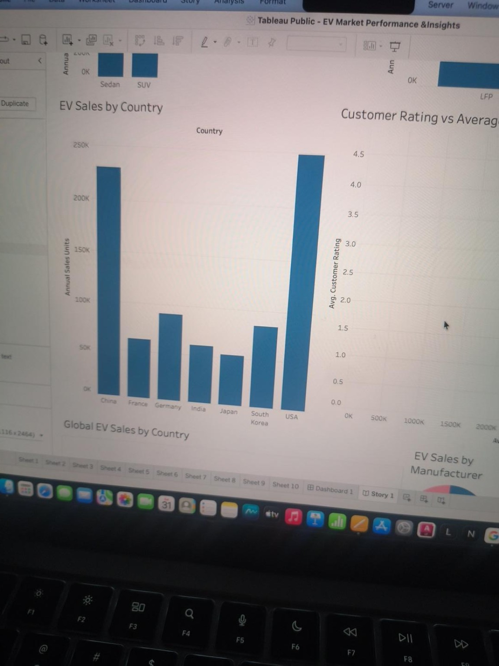
Scatter plot detail
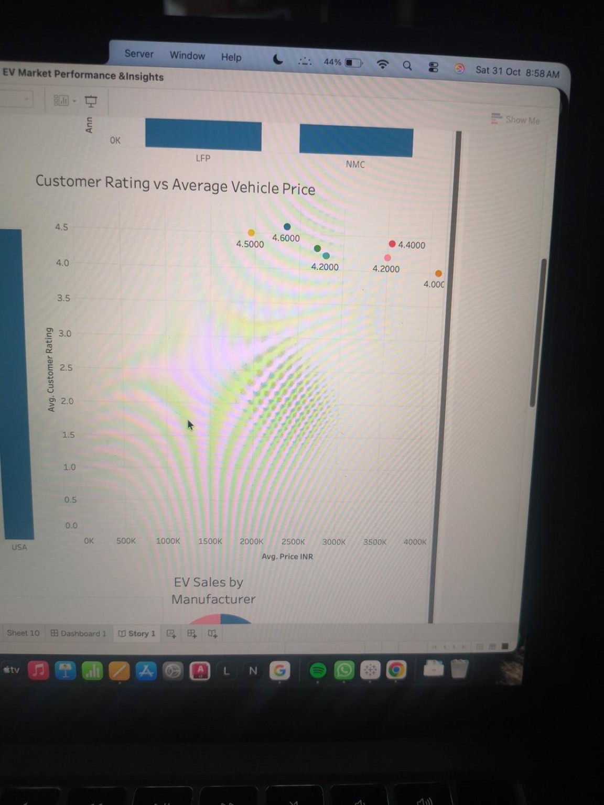
Country map and manufacturer pie chart
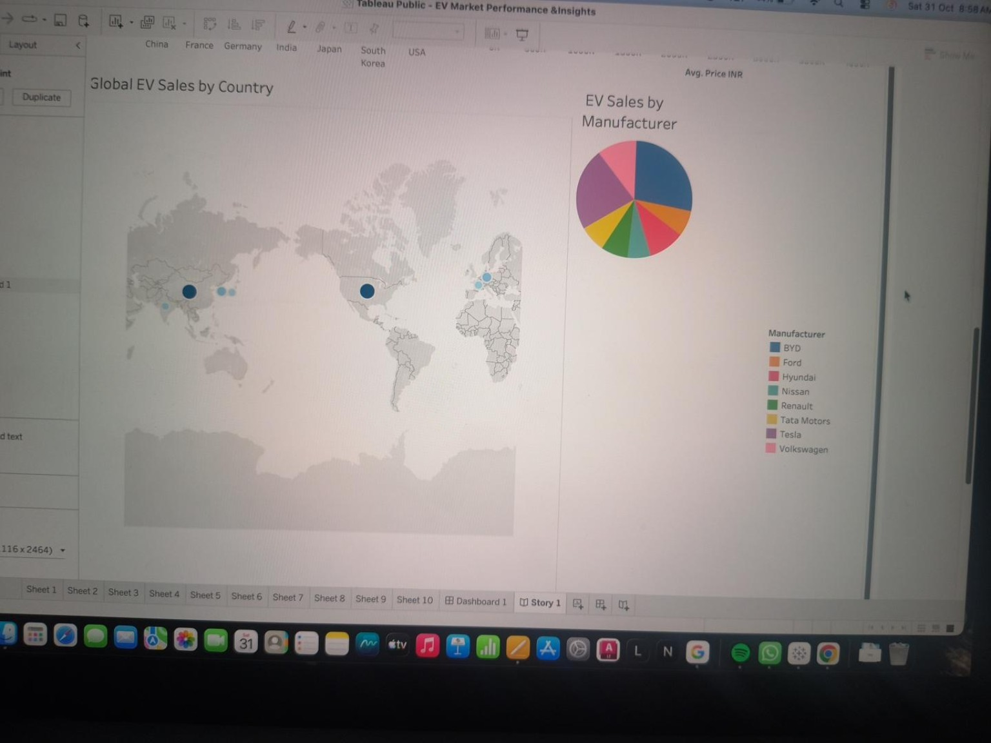
Note: The observations describe the values and patterns visible in the supplied Tableau screenshots. Before final submission, verify that the published workbook is connected to the intended project dataset and that all KPI totals reconcile with the source data.

